INVITATION

POLISH OPEN CHAMPIONSHIPS
Lubin, 30th August -2nd September 2012

PART OF THE INTERNATIONAL SERIES,
2012/2013 BADMINTON EUROPE CIRCUIT
&
A WORLD RANKING TOURNAMENT

PRIZE MONEY 5 000 $

1 | Sanctioned by | Badminton World Federation and Badminton Europe
2 | National Organization | Polish Badminton Association  ul. Dzika 15/11  00-172 Warszawa  Phone/Fax: +48 22 412 10 31  e-mail: sekretariat@pzbad.pl sekretariat@pzbad.pl
3 | Tournament  Organization  &  Venue | Community Centre “Wzgorze Zamkowe”  Pruzi Street 7, 59-300 LUBIN  Phone: (+48) 76 749 69 69  Fax: (+48) 76 749 69 68  e-mail: lubincup@gmail.com  www. www.badminton-lubin.com  Venue: School Sport Hall No. 14 Lubin Norwida 10 Street
4 | Events | men’s singles, women’s singles, men’s doubles, women’s doubles, mixed doubles
5 | Entry limits | In singles: 32 in main draw. In doubles: 24 in main draw.
6 | System | knock-out
7 | Tournament director | Mr. Marek ZAWADKA e-mail:lotka.lubin@gmail.com
8 | Referee | Mr. Erik LIGTVOET (NED) e-mail: eligtvoet@badminton.nl
9 | Deputy referee | Mr. Piotr AGACINSKI (POL) e-mail: piotr.agacinski@gmail.com
10 | Time Schedule  (as expected) | Thursday, 30th August 2012 –at. 9.00 AM -Qualification tournament  Friday, 31st August 2012 at 9.00 – Main tournament start  Saturday, 1st September 2012 at 10.00 – Quarterfinals  Saturday, 1st September 2012 at 17.00 - Semifinals  Sunday, 2nd September 2012 at 10.00 – Finals  The exact timetable will be presented after draw.
11 | Entries | All entries must be made by using the BWF Online Entry System. Entries must be submitted no later than Tuesday 7th August 2012 at 23.59 BWF HQ time (GMT +08.00)  http://bwf.tournamentsoftware.com/sport/tournament.aspx?id=EC795149-745A-4590-A357-6A81331FC471entsoftware.com/sport/tournament.aspx?id=EC795149-No late entries will be accepted.  Players cannot be entered unless they already have a BWF ID-number. In case you wish to enter players who do not have a BWF ID-number, please contact the BWF office well in advance of the tournament, so that the players concerned can get a BWF ID-number before the closing date of the tournament.
12 | Entry closing date | 7th August 2012
13 | Entry fees | Singles: 40,00 € per player  Doubles: 30,00 € per player per event  Entry fees has to be transferred till 7th August 2012 in € to the following account  Account owner: OSRODEK KULTURY WZGORZE ZAMKOWE W LUBINIE  Bank: BNP PARIBAS BANK POLSKA SA  Account No: 65 1600 1462 1843 8578 0000 0001  IBAN: PL65 1600 1462 1843 8578 0000 0001  SWIFT- BIC: PPABPLPK  If entry fees are not paid according to the regulations, the players concerned are not allowed to play.  The member association that enters a player into a circuit tournament is responsible for paying the entry fees for that player.  For all the players withdrawing in the time between the closing date and the beginning of the tournament the organizers can invoice the entry fee to the relevant member association.
14 | Shuttles | Yonex AS 50
15 | Courts | 4 Victor
16 | Prize money | 5 000 $ = € (currency from 28th March 2012) abroad player’s prize money will be according tax law taxed with 10%  MS WS MD WD XD  Winner 1000 1000 800 800 800  Runner-up 300  All prices in €  The Organizer will pay the prize money in cash during the closing ceremony. The prize money will be awarded only to those players who attend the closing ceremony.
17 | Conditions | The Polish Open Championships will be conducted under the BWF Competition Regulations and in accordance with the regulations of the Badminton Europe Circuit. Players shall not plan their departure less than two (2) hours after their last match is planned to conclude. If a player/pair is unable to compete due to early departure, such a player/pair shall lose all the Circuit Ranking points gained at the particular tournament and BADMINTON EUROPE shall propose to BWF that the gained BWF ranking points are also removed. (Regulation 9.5 in Badminton Europe’s Circuit Regulations.
18 | Clothing and  advertising | The Polish Open Championships will be conducted according to the BWF Regulations 19-23 on advertising and clothing. For all BE Circuit tournaments, According to the Circuit Regulations 18.2 and 18.3 name on the back of the shirt is mandatory for the semi-finals and finals. It is mandatory for the semi-finals and finals that partners in doubles wear the same colour.
19 | Withdrawals | Please ensure that the organizer will be informed immediately when a player has to withdraw, together with the reason.  Attention:  Any withdrawal after the Sunday immediately preceding the draw, for any reason whatsoever, renders the Member Association concerned liable to an amount of $ 150,00 for the inconvenience caused by the withdrawal (as defined in BWF General Competition Regulations).
20 | Visa | Important for all players who need visa for Poland. Please request immediately from Polish Badminton Association an official INVITATION LETTER and apply as soon as possible. (e-mail: a.bieleniewicz@pzbad.pl)
21 | Drug testing | According to Polish law drug testing may by carried out an a random basis at any time.
22 | Betting | There will be betting on offer from this event. Betting is however not allowed to be made by players or officials connected to the event either in person or through a third party. Participants may therefore not make bets on the Event or procure through third parties the making of bets with a betting agency. Participants who, in violation of this prohibition, nevertheless make or procure through third parties the making of bets with betting agencies shall be immediately disqualified from participation in the Event and are liable for legal prosecution. Similarly manipulation of games will be met with disqualification and possible legal prosecution. Any violation mentioned above is also a breach of Player's Code of Conduct (Art. 5.2.) and will be sanctioned by BWF.
23 | Payments | All payments (accommodation, entry fee, meals etc.) has to be transferred till 7th August 2012 in € to the following account  Account owner: OSRODEK KULTURY WZGORZE ZAMKOWE W LUBINIE  Bank: BNP PARIBAS BANK POLSKA SA  Account No: 65 1600 1462 1843 8578 0000 0001  IBAN: PL65 1600 1462 1843 8578 0000 0001  SWIFT- BIC: PPABPLPK
24 | Accommodation | Different Tournament Hotels are offered for tournament.  Reservation to be made together with the entries and meals till  7th August 2012 on the enclosed form.  The Hotels will be offered in three different categories:  4- star category (distance to facility – 25 km):  65 € per night in a single room  78 € per night in a double room  QUBUS HOTEL LEGNICA  Skarbowa 2 Street  59- 220 LEGNICA  phone: (+48) 76 866 2 100  fax: (+48) 76 866 2 200  e-mail:marketing_legnica@qubushotel.com  legnica@qubushotel.com  website:www.qubushotel.com  3- star category (distance to facility – 20 km):  68 € per night in a single room  81 € per night in a double room  AQUA HOTEL POLKOWICE  Mlynska 6 Street  phone: (+48) 76 746 27 00  fax: (+48) 76 746 28 00  59-100 POLKOWICE  e-mail: recepcja@aquahotel.pl  website: www.aquahotel.pl  2-star category (distance to facility- 2 km):  32 € per night in a single room  45 € per night in a double room  45 € per night in a triple room  HOTEL BARON LUBIN  Marii Sklodowskiej – Curie 88 Street  59-300 LUBIN  phone: (+48) 76 847 86 00  fax: (+48) 76 847 32 86  website: www.baron.lubin.pl  Included in the price:  - overnight stay/ breakfast/internet  - transport from the airport to the venue  - transport from the hotel to the sports facility.  Organizer will not be responsible for any loss in the hotels or the venue.  The requirements for accommodation will be satisfied as much as possible. The organizer has the authority to make any changes in accommodation if necessary in order to arrange accommodation for all teams.  If you wish to make hotel- reservations, please complete and return the attached forms no later than by 7th August 2012 to:  e-mail: lubincup@gmail.com  Event Office  Polish Open 2012  Phone: (+48) 76 749 69 69  Fax: (+48) 76 749 69 68
25 | Meals | Organizer provides food on the place:  “ROY” Restaurant - 200 m  Krupinskiego 28 Street  59 – 300 LUBIN  Phone: (+48) 76 842 52 04  e-mail: restauracja@roy.lubin.pl re  If you wish to make meals- reservations, please complete and return the attached forms no later than by 7th August 2012 to:  e-mail: galaretka84@gmail.com  www: www.badminton-lubin.com
26 | Airport | Airport Wroclaw Strachowice  Transport from the Airport to the Hotels and from Hotels to the Airport provides the Organizer.  The Airport is located 65 km Legnica, 85 Lubin, 100 km Polowice to hotels.  Please notify the tournament office about your airport pick up time until  7th August 2012. This information should be e-mailed to:  lubincup@gmail.com
27 | Medical service | A doctor and a physician will be present in the sports hall during the tournament.
28 | Insurance | To be arranged individually by participants.
29 | Press-office | Ms. Karolina NOWAK  e-mail: lubincup@gmail.com, galaretka84@gmail.com
30 | Tournament websites | www.badminton-lubin.com www.polish-open.pl
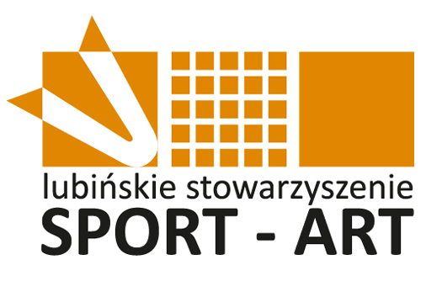
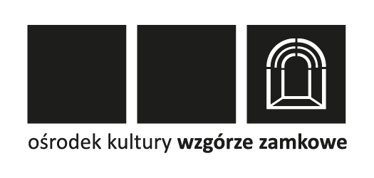
ACCOMMODATION FORM

Closing date for bookings: 7th August 2012.

Name of Association:
Name of contact person:
Phone/fax:
E-mail:
Category of the Hotel | **** | *** | **

Night of | Wednesday  29.08.2012 | Thursday  30.08.2012 | Friday  31.08.2012 | Saturday  01.09.2012 | Sunday  02.09.2012
Single room
Number of PEOPLE in double room

Local transport: Provided by the organizer between the official hotels and the sports hall. Bus Timetable will be given on the official tournament page
www.badminton-lubin.com .

If you wish to make hotel- reservations for Monday or Tuesday (27.08-28.08.2012):
This information should be e-mailed to the following e-mail address:
lubincup@gmail.com

Date:.............................

Signed:..........................

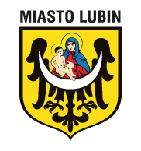
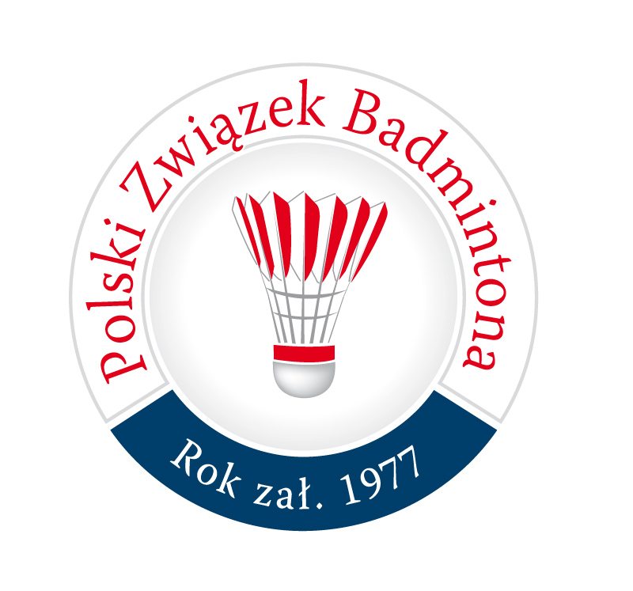

MEALS FORM

Closing date for bookings: 7th August 2012.

Name of Association:
Name of contact person:
Phone/fax:
E-mail:

Number of | Wednesday  29.08.2012 | Thursday  30.08.2012 | Friday  31.08.2012 | Saturday  01.09.2012 | Sunday  02.09.2012
Lunch
Dinner

If you wish to make meals- reservations for Monday or Tuesday (27.08-28.08.2012) :
This information should be e-mailed to the following e-mail address:
lubincup@gmail.com

Date:.............................

Signed:..........................
TRANSPORT RESERVATION FORM

Closing date for bookings: 7th August 2012

Name of Association:
Name of contact person:
Phone/fax:
E-mail:

Means of transport
- by car
- by train
- by plane
- others..........................(specify)

 | Arrival | Departure
Date
Place (station/airport)
Time
Number of persons
(staff included)
Flight number
Train number
Coming from / Going to

Organizer provides only transport from the Airport Wroclaw Strachowice to the Hotels and from Hotels to the Airport Wroclaw Strachowice

Date:............................

Signed:.........................

